__________________________________________________

Response to the NDIS Code of Conduct Discussion Paper

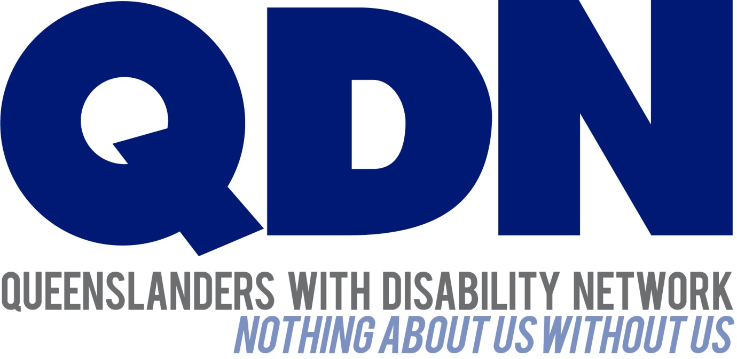

About Queenslanders with Disability Network (QDN)
QDN is an organisation of, for, and with people with disability. The organisation’s motto is “nothing about us without us.” QDN operates a state-wide network of over 700 members and 300 supporters who provide information, feedback and views from a consumer perspective to inform systemic policy feedback to Government and peak bodies. QDN also provides information and referral support to people with disability.

QDN Consultation
QDN’s submission is informed by the lived experience of QDN members with disability and key allies. QDN’s work in providing feedback and input into systemic policy issues is based upon the organisation’s core values (Appendix A) and the place of people with disability in an inclusive Australian society.

Introduction
QDN is pleased to provide feedback on the NDIS Code of Conduct, an aspect of the NDIS Quality and Safeguarding Framework. The Code of Conduct will apply to any person or service delivering NDIS supports. A code of conduct is important to:
- empower people with disability in relation to their rights;
- outline expectations for providers and individual workers;
- shape the behaviour and culture of organisations; and
- provide a mechanism to enforce consequences if workers and providers do not meet expectations.

QDN supports the development of an NDIS Code of Conduct underpinned by a broad and robust legislative and policy framework, including key human rights instruments. QDN believes the discussion paper provides a sound basis for broader discussion and consultation on what should be included in the Code of Conduct. QDN believes people with disability have a vital role in informing the development of the Code of Conduct so that the experiences of people with disability are acknowledged, participants can access safe and quality services and the NDIS can achieve its goal of truly transformational change in the lives of people with disability.
QDN’s response to the discussion paper will include general comments on the Code of Conduct with recommendations and suggestions for inclusion to ensure the Code of Conduct is a robust document that reflects best practice in NDIS service provision, is easily understood by all parties and has clear mechanisms of enforceability.

General Feedback
QDN supports the development of an NDIS Code of Conduct and sees its development as an essential safeguard for people with disability as they enter this new service environment. It is important that all legislative and policy instruments ensure people with disability are empowered to have choice and control over the services they receive. QDN believes the new NDIS Quality and Safeguards Commission overseeing the Code of Conduct needs the independence and authority to act in the best interest of people with disability.
QDN strongly asserts that alongside the Code of Conduct there needs to be effective, independent advocacy and funded programs with a dedicated focus on peer support and leadership, awareness raising and assertiveness training to support people with disability to identify when a breach of the Code of Conduct has occurred and feel empowered to raise a breach. QDN strongly asserts the need for an investment in training of NDIS participants and workers. QDN also strongly believes that this process needs to be accessible to all participants of the NDIS, especially those who are more marginalised and experience additional disadvantage and challenges.
QDN members are aware of the history of disempowerment experienced by the power imbalance that has existed for generations between people with disability and the service system. Despite the transformational nature of the NDIS, this imbalance will take time to redress. Many people with disability will remain extremely vulnerable if they have no one to support them to speak up. QDN also asserts there needs to be a process of Appeal if a matter is investigated by the Commission and a participant disagrees with the outcome of the investigation.
QDN supports that the Code of Conduct is enforceable by law, including a range of compliance, enforcement actions and sanctions for breaches of the Code. QDN also notes that the Code will come into effect once the NDIS is at full-scheme. QDN members raised the importance of the legal instruments of sanctions and breaches are proportioned to the severity of illegal act, in line with what is contained within legal responses in other parts of the community to similar acts. This will ensure people with disability are recognised as full citizens, with rights to legal protections and the delivery of safe and quality services within the NDIS. QDN anticipates further opportunities to provide informed feedback on proposed sanctions and enforcement actions in the near future. QDN members also raised the importance of transitional arrangements in place to protect people with disability as we move to full scheme.
QDN also notes that the Code of Conduct will apply to all providers and workers who are funded under the NDIS, regardless of whether they are registered, or whether they receive funding through individual plans or contracted services. QDN commends this but recommends that the NDIA provide further clarity regarding how this will apply to unregistered providers, and how the compliance and regulations will be monitored and implemented.
QDN members were resolute that incidences such as abuse, neglect, exploitation and sexual misconduct should be automatically reported to the relevant external authorities and the Commission, with appropriate support offered to the victims, and not just resolved at the service level.
QDN notes that registered providers will also be required to notify the Commission of reportable incidents, including incidents involving abuse, neglect, violence and/or exploitation. QDN commends this requirement but believes this obligation should also apply to unregistered providers.
QDN notes the recommendation of a compulsory orientation module for registered providers delivering supports and for all workers of registered providers engaged in the delivery of NDIS funded supports. QDN also notes that that information on the Code of Conduct and its requirements will be included in the orientation module. QDN supports the training of workers and requirements for compulsory orientation, and strongly asserts that the implementation and cost of compliance for this should not impact upon the funded reasonable and necessary supports within a participants existing plan.
QDN also notes that anyone will be able to make a complaint about NDIS funded supports including breaches of the Code of Conduct and that in the first instance, people should contact the relevant service provider. QDN believes this highlights the need for independent advocacy and clear policies and guidelines supporting people to speak up and have freedom from retribution so that people can be safe to raise issues and breaches of the Code of Conduct in relation to the NDIS services they receive.
Some QDN members expressed concerns that the online survey about the NDIS Code of Conduct on the engage-dss website was limited in scope and needed more opportunities to give feedback on areas that should be covered in the Code of Conduct.

Feedback specific to the obligations
QDN agrees in principle with the obligations outlined in the Code of Conduct Discussion paper. QDN members felt each obligation was of equal importance and were specific to upholding the rights of people with disability and ethical human service provision.
Furthermore, while some of these were implicit in the proposed obligations, QDN suggests the following additional obligations with specific wording around the following:
- Act in ways that uphold anti-discriminatory practices
- Provide information in accessible formats
- Demonstrate clear procedures for declaring and managing conflicts of interest – particularly in a commercial context
- Promote freedom from retribution for NDIS participants and workers who raise breaches
- Uphold and support the right to take risks (dignity of risk)
- Demonstrate competence and standards in working with guide and assistance dogs
QDN makes the following comments about specifically stated obligations in the discussion paper:

Promote individual rights to freedom of expression, self-determination and decision-making
Australia’s obligations under the Convention on the Rights of Persons with Disabilities (CRPD) makes clear statements on protecting people’s rights to freedom of expression, self-determination, decision-making and choice of where and with whom to live. This is particularly evident in:
- Article 12: Equal recognition before the law;
- Article 19: Living independently and being included in the community which specifically states: Persons with disabilities have the opportunity to choose their place of residence and where and with whom they live on an equal basis with others and are not obliged to live in a particular living arrangement; and
- Article 21: Freedom of expression of opinion and access to information.
Therefore, QDN members felt this obligation in the Code of Conduct would be strengthened by including the following expectation:
- stopping practices that limit the lives of people with disability, such as congregating people based on disability, forced co-tenancy, and other institutional practices.

Actively prevent all forms of violence, exploitation, neglect and abuse
To fully realise this obligation QDN members felt it needed to include the following expectation:
- Must provide protection and support for whistle-blowers

Act with integrity, honesty and transparency
QDN members felt strongly that this obligation needed to include an expectation that services are value for money and subject to similar obligations and expectations as services on the free-market. QDN believes there is a need for minimum standards around consumer rights and choice.

Raise and act on concerns about matters that may impact on the quality and safety of supports provided to people with disability
Alongside quality assurance procedures outlined in the discussion paper such as day-to-day feedback, formal consultation and engagement, regular satisfaction surveys or consumer groups, it is essential that people with disability feel safe to make a complaint or provide negative feedback without fear of adverse consequences or loss of service. People with disability must continue to have access to effective, independent advocacy.

Not engage in sexual misconduct
QDN members felt the language around sexual misconduct needed strengthening. The discussion paper states: “Sexual misconduct is a broad term encompassing any unwelcome behaviour of a sexual nature”. QDN presumes that any sexual behaviour, whether unwelcome or not, constitutes a serious breach of the NDIS Code of Conduct in regards to the nature of the participant- worker relationship.
Furthermore, QDN believes the NDIS Code of Conduct should include legal definitions of what constitutes sexual misconduct such as grooming, sexual assault, rape and sodomy.
QDN members felt that this section requires more detail about what is required of providers in incidents of sexual misconduct, such as:
- Reporting incidences of sexual abuse to relevant authorities
- Actions taken against worker/ suspect – suspension, dismissal, criminal proceedings
- Support given to victim – advocacy, counselling, support with reporting incident, any medical procedure and care that occurs post incident, support to give evidence in court, options to change services, compensation and redress

Keep appropriate records
QDN members felt that participants should be able to access any records kept about them on request.

Conclusion
QDN is pleased to provide this feedback on the proposed NDIS Code of Conduct. A strong Code of Conduct sets clear expectations of worker and provider conduct, details a range of compliance, enforcement actions and sanctions for breaches of the Code and helps to enforce safeguards and quality standards in relation to service provision to people with disability under the NDIS.
QDN looks forward to further opportunities to contribute to the development of a robust NDIS Code of Conduct grounded in human rights principles and legislative base. This will ensure people with disability are recognised as full citizens, with rights to legal protections and the delivery of safe and quality services within the NDIS.

QDN – 12 June, 2017

Appendix 1. QDN’s Value Statement on People with Disability
QDN’s work in providing feedback and input into systemic policy issues is based upon the organisation’s core values and the place of people with disability in an inclusive Australian society.
QDN believes that:
- all people with disability have a right to a place in the community and have contributions to make to community. This is as empowered, free citizens who are as valued, present, participating and welcomed as members of any dynamic and diverse society
- the place of people with disability in the community is not just about people with disability having a house in the community. Core to this is that they are welcomed in the community as ordinary citizens, where they are genuinely given opportunities to contribute and actively participate. People with disability need to be in communities where their individuality, their talents and their lived experiences of disability are recognised and acknowledged
- culturally and historically, people with disability are not afforded the same value, opportunities or access to community life
- any inclusion in community for people with disability is conditional and vulnerable to withdrawal
- many people with disability in Queensland are excluded from the most basic experiences of ordinary lives
- current exclusionary practices are unacceptable and must be challenged
- these issues affect not only people with disability but the whole community
- the responsibility is shared. It lies within government (federal, state and local) and the community at large, to ensure that people with disability have a place and are resourced to belong in community.

